LOCAL SPORTS GROUND SLOT BOOKER
@CREATIVITY THINK (9483175986/7019689991)

ABSTRACT:
Local Sports Ground Slot Booker is a web-based platform designed to streamline the process of reserving sports grounds, turf fields, and community play areas. Users can browse available grounds, view booking calendars, check slot availability, and book preferred timings. Teams and players can manage their bookings, view history, and maintain simple profiles. Administrators can add grounds, configure slot timings, approve or cancel bookings, and block slots for maintenance. The system also offers basic usage analytics to help turf owners or community managers track ground utilization. The application is built using Django REST Framework for the backend and React with React-Calendar for the frontend interface..

INTRODUCTION OF THE PROJECT:
Sports grounds and community play areas often face challenges such as unorganized booking systems, double-booking issues, and lack of transparency in slot availability. Manual booking methods—phone calls, paper logs, WhatsApp groups—lead to confusion and inefficient ground management.
The Local Sports Ground Slot Booker resolves these issues by offering a structured digital booking system where users can view real-time availability and book slots instantly. Admins can approve or cancel bookings and block certain dates for repairs or events. The platform also provides usage analytics, enabling better planning and ground utilization tracking..

PROJECT OBJECTIVES:

• Provide a clean interface to browse available sports grounds
• Allow users and teams to register and maintain basic profiles
• Display slot availability using an interactive calendar
• Enable booking, cancellation, and history tracking
• Allow admins to approve or cancel bookings
• Support blocking of slots for maintenance
• Display pricing (if applicable) as “display only – pay offline”
• Offer basic analytics like peak usage time/day
• Provide exportable booking logs for record-keeping

PROBLEM OF THE STATEMENT:
Community sports facilities frequently struggle with inefficient booking workflows, leading to confusion and double bookings. Many grounds lack an accessible real-time calendar to display availability, making scheduling difficult for local teams and schools. This project aims to bridge that gap with a centralized and user-friendly slot-booking system that enhances transparency, prevents conflicts, and improves ground management efficiency..

MOTIVATION OF THE PROJECT:
• To modernize the traditional offline ground booking process
• To eliminate double-booking through real-time slot visibility
• To simplify the booking experience for players and teams
• To provide admins with better control and analytics
• To maintain structured records using digital logs
• To support community sports culture by enabling easy access to grounds

BLOCK DAIGRAM OF PROJECT:

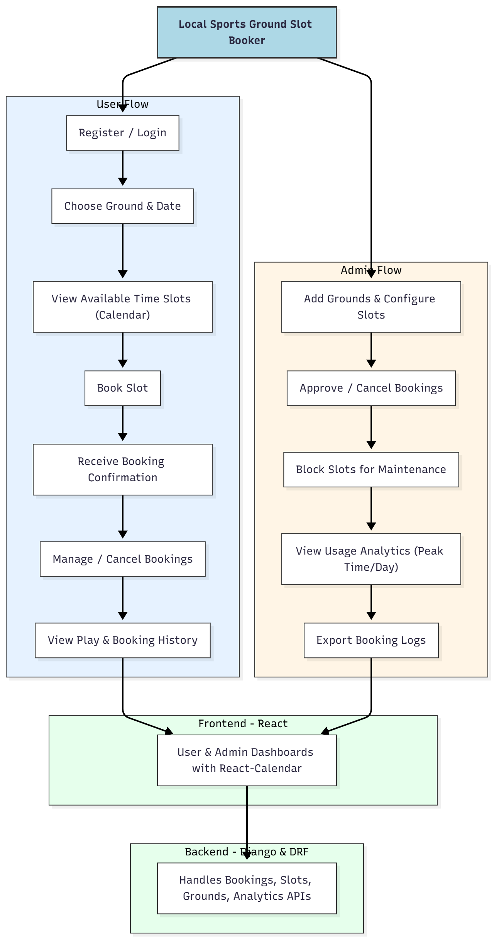

WORKING OF THE PROJECT:
Users register or log in to the platform to browse grounds and choose a date from the interactive calendar. The system fetches available time slots, enabling users to book one instantly. Upon booking, a confirmation is shown, and users can later modify or cancel their reservations. Their entire booking history is accessible on the dashboard.
Admins manage the backend by adding new grounds, adjusting time slots, and approving or canceling bookings when needed. They can also block slots for maintenance or special events. The dashboard provides basic analytics showing ground usage patterns, and admins can export logs for monthly or yearly reporting..

SOFTWARE REQUIREMENT:
- Backend:
  - Python 3.x
  - Django
  - Django REST Framework
  - SQLite/PostgreSQL
- Frontend:
  - Node.js and npm
  - React.js
  - Axios
- Development Tools:
  - Visual Studio Code
  - Postman (for testing APIs)
  - Git/GitHub (for version control)
- Server/Deployment (Optional):
  - Gunicorn, Nginx, or Heroku/AWS for hosting

ADVANTAGES OF THE PROJECT:

• Real-time slot visibility prevents double bookings
• Simple and fast booking interface for players and teams
• Easy administrative control over ground schedules
• Supports offline payment workflows when needed
• Calendar-based visualization enhances user clarity
• Exportable logs help with accounting and event planning
• Usage analytics assist in optimizing ground availability
• Reduces manual coordination and miscommunication

APPLICATIONS OF THE PROJECT:
• School and college sports grounds
• Community grounds and municipal parks
• Private turf owners and stadiums
• Corporate sports facilities
• Local sports academies

REFERENCES:

- Django REST Framework Documentation — Django Software Foundation. Django Documentation. Available: https://docs.djangoproject.com/
- Django REST Framework. DRF Documentation. Available: https://www.django-rest-framework.org/
- React. React Official Documentation. Available: https://reactjs.org/docs/getting-started.html
- Redux. Redux Documentation. Available: https://redux.js.org/introduction/getting-started
- PostgreSQL Global Development Group. PostgreSQL Documentation. Available: https://www.postgresql.org/docs/
- MySQL. MySQL Reference Manual. Available: https://dev.mysql.com/doc/
- Git. Git Documentation. Available: https://git-scm.com/doc
- Node.js. Node.js Documentation. Available: https://nodejs.org/en/docs/
- Axios. Axios Documentation. Available: https://axios-http.com/docs/intro
- Socket.io Documentation – https://socket.io/docs/

